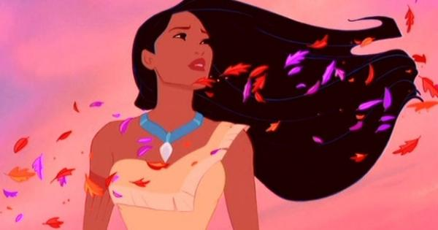
Pocahontas and Worldview
During and after viewing Pocahontas answer the following questions regarding Worldview
- What worldview element causes John Smith and Pocahontas to meet? How do you know?

- What worldview element is the motivation for Governor Ratcliffe to go the New World? What evidence is there from the movie that supports your answer?
- Upon arriving in the New World what do the English see? What do they say or do that suggests what they believe?

- Identify three differences of the First Nations beliefs and/or society compared to the English.

- Identify the significance of Grandmother Willow to the First Nation belief system.

- How did the element Time affect the worldview of the First Nations?
- How did the element Geography affect the worldview of the English?

- How does the song “Savages” depict each of the differing worldviews?

- Compare the difference in Knowledge between the two societies.

- Whose worldview changed throughout the movie? How do you know?

