Aztec Gods
The Aztec religion revolved around various gods which they adopted into their lives over the course of time. Each human aspect of life for the Aztecs was guided by a patron god and therefore there are literally thousands of gods. The daily activities and rituals of the Aztec people were also guided by these gods, and to create balance of power, the gods were offered human sacrifices all throughout a special calendar that marked festivities for each of them.

The Aztecs believed in heaven and hell, and they worshipped the sun, the moon and the stars. The beginning of the world in Aztec lore had its origin told through a tale called the Legend of the Suns. The Aztec Empire was at the 5th cycle of creation and destruction, and each world called suns was destroyed and revived again in a 52 year cycle.

The main Aztec deity was the creator god Ometeotl, who was both male and female and therefore he was able to create the other gods. Ometeotl created the other four main Aztec gods, first was god of the North, Xipe Totec, second was god of the South, Huizilopochtli, third was god of the East, Quetzalcoatl and fourth was god of the West, Tezcatlipoca. Together these four Aztec gods were known as the four Tezcatlipocas, and the directions pointed to their home as being the centre of the universe in the eyes of the Aztec people.

Your Assignment—The Five Suns
The Aztecs as we mentioned, believed in a 52 year cycle for each Sun or World before its destruction, and this focused around the five suns.

· The first Sun was destroyed by floods and everyone turned into fish.
· The second Sun was eliminated by jaguars.
· The third Sun was ended by a rain of fire.
· The fourth Sun was wiped out by a storm and people transformed into monkeys.

The Fifth Sun was not yet destroyed when the Spanish arrived - your job is to take the knowledge you’ve learnt through this unit and assign the sun’s destruction to it.

Requirements
1. Draw a picture of the God and give him/her a name
example: Tlaltecuhtli – Earth goddess
your picture must be coloured, and take up a full page
2. Decide how this God ended the fifth sun write 2-4 paragraphs behind your legend
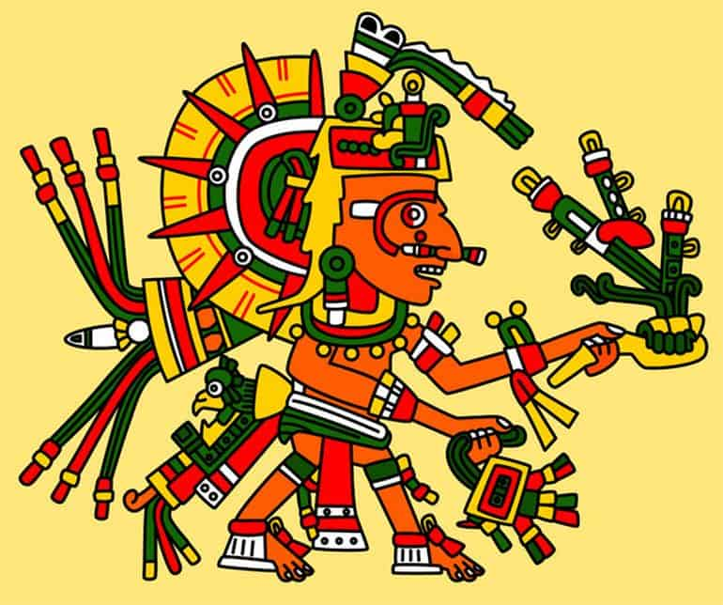

 | Chief | Jaguar | Peasant | Slave
Legend | Created an interesting and creative story in correct sequence leaving out no important parts of story. | Created an interesting story in correct sequence leaving out few important details | Created a story leaving out several important details | Did not a create a story that was sequential , did not meet requirement
Character | Students has put in substantial detail, time and effort into creating and depicting character | Student has put in good detail, time and effort into creating and depicting character | Student has put in little detail, time and effort into creating and depicting character | Student has not put in the required detail, time and effort into creating character
Knowledge | Student clearly has a strong understanding of Aztec and Spanish content | Student has a good understanding of Aztec and Spanish content | Student has some understanding of Aztec and Spanish content | Students has does understanding content

